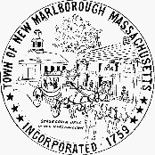 | COMMONWEALTH OF MASSACHUSETTS  TOWN NEW MARLBOROUGH  OFFICE OF THE SELECT BOARD  807 Mill River Southfield Road, Mill River, MA 01244

Notice of Public Listening Session

Proposed Local Room Occupancy Tax

Fire House Conference Room
205 Norfolk Rd, Southfield

Monday, March 11, 2024
6:30 pm

The Select Board will present information, answer questions, and hear comments on this proposed tax.

Massachusetts has a state room occupancy excise tax rate of 5.7%. In addition to the state tax, the Town of New Marlborough may vote to charge a local option room occupancy tax (up to 6%) and a community impact fee (up to 3%).
The room occupancy excise tax applies to room rentals of 90 days or less in hotels, motels, bed and breakfast establishments, and lodging houses. The room occupancy excise also applies to short-term rentals of property for 31 days or less. The community impact fee on short term rentals is an additional tax that applies to operators who have more than one property in the locality or is renting an owner occupied 2 or 3 family house on a short term rental basis.
Additional information can be found here: Room Occupancy Excise Tax | Mass.gov

